# CS 255 System Design Document

By Ryan Mitchell

## UML Diagrams

### UML Use Case Diagram

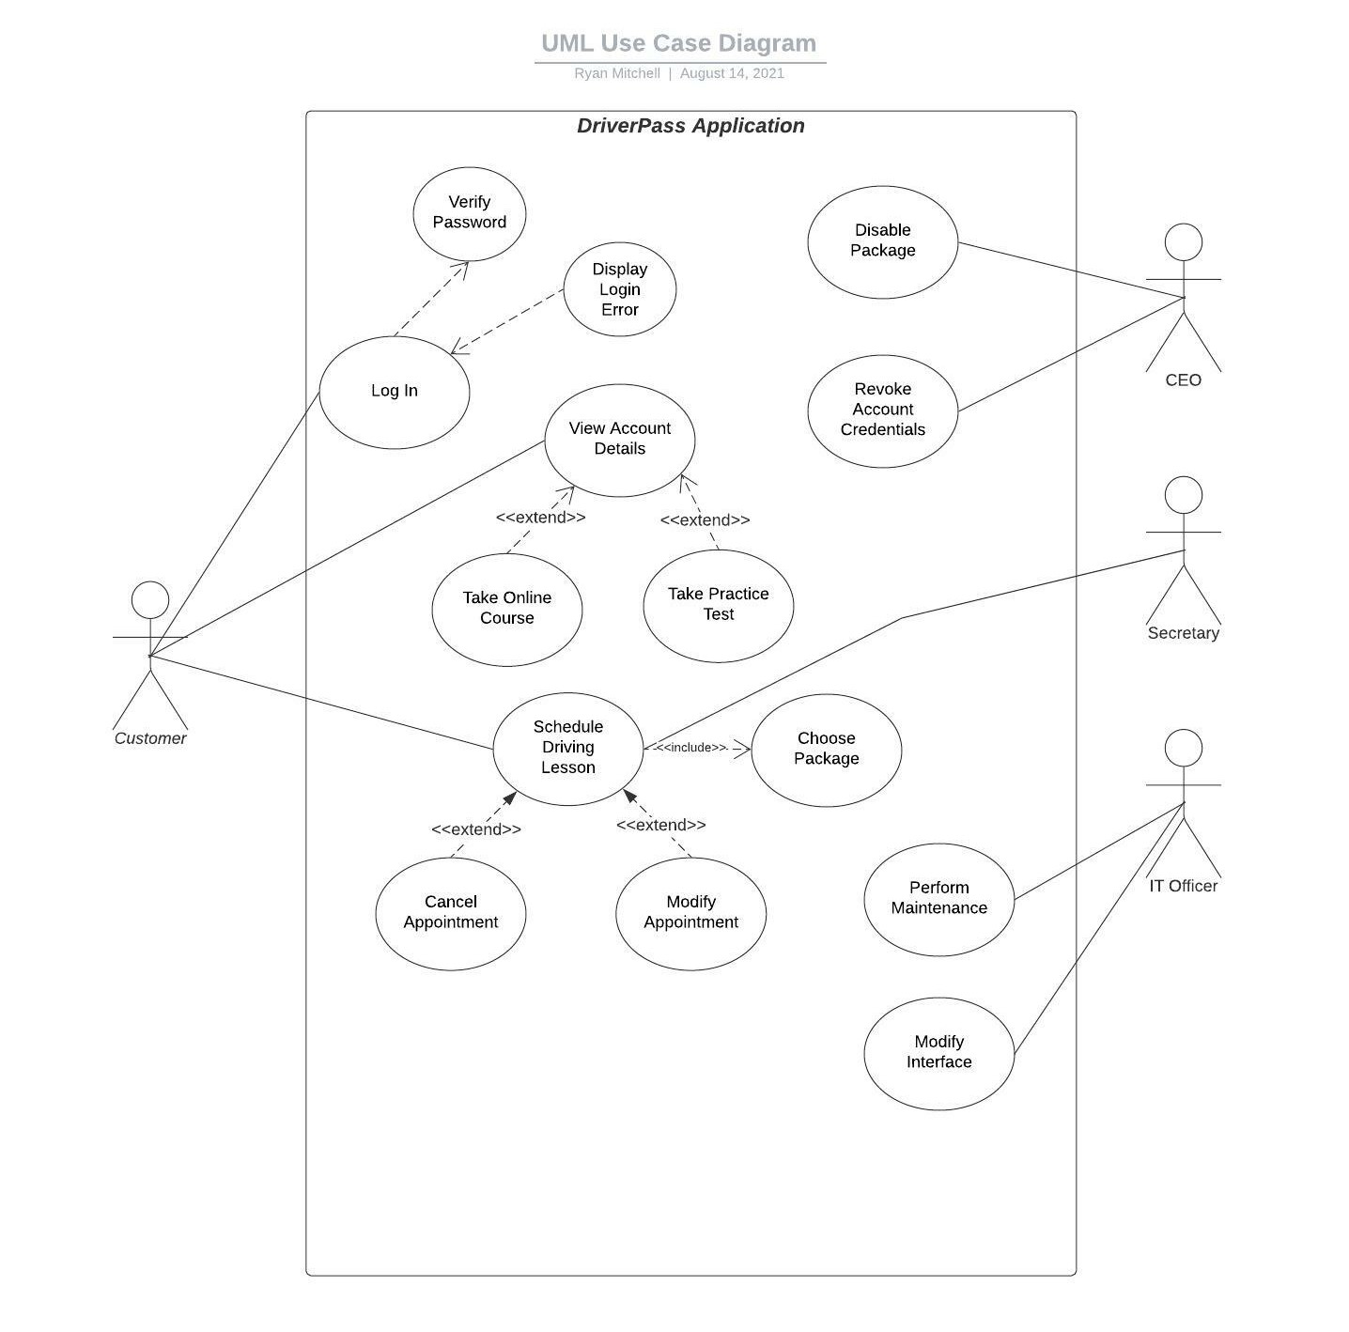

### UML Activity Diagrams

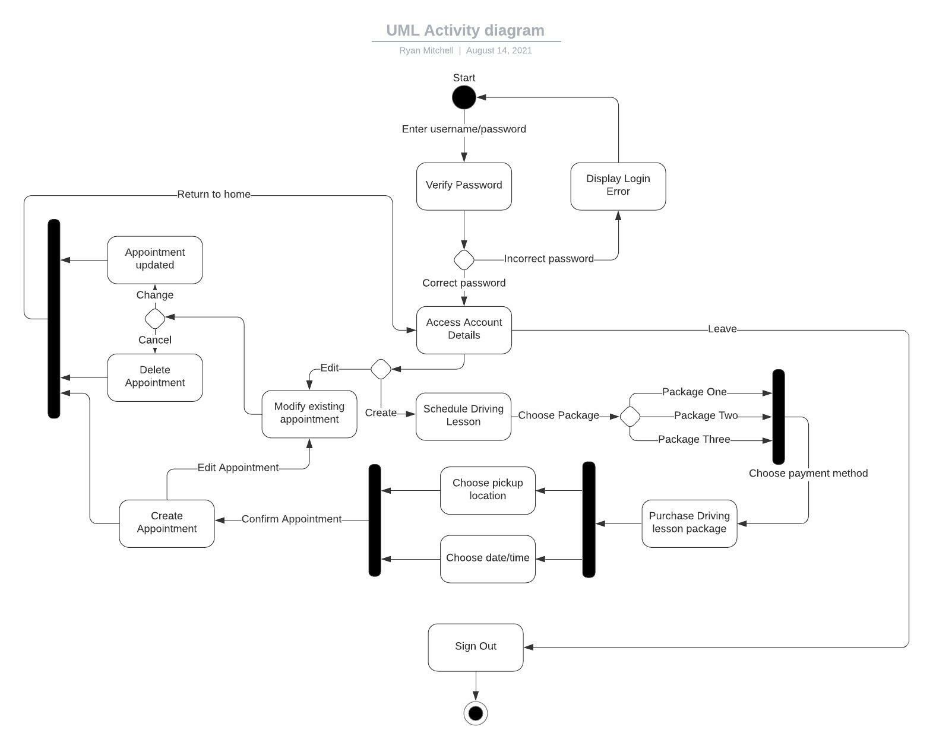

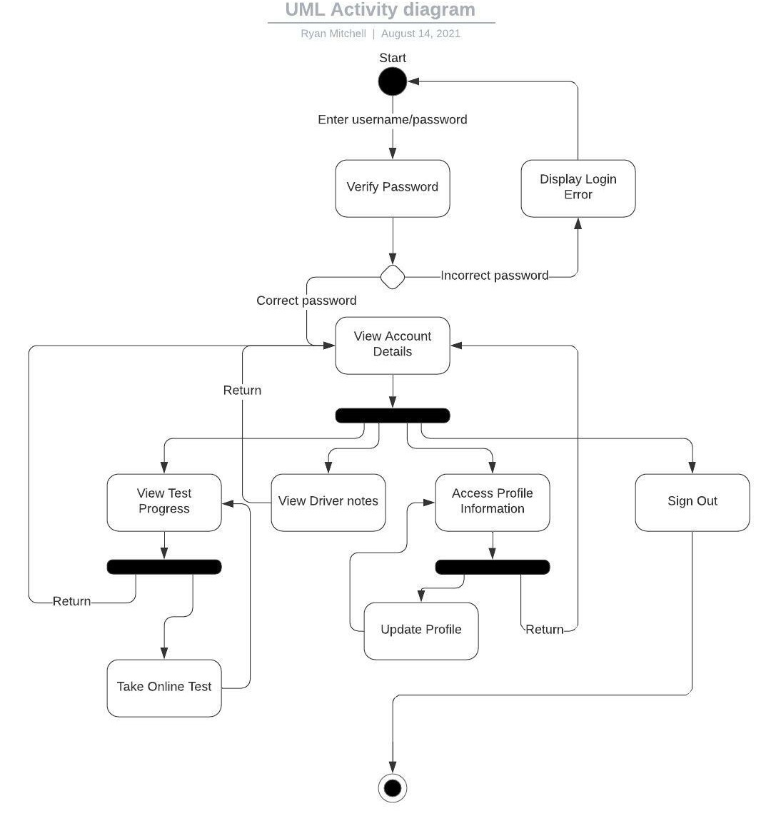

### UML Sequence Diagram

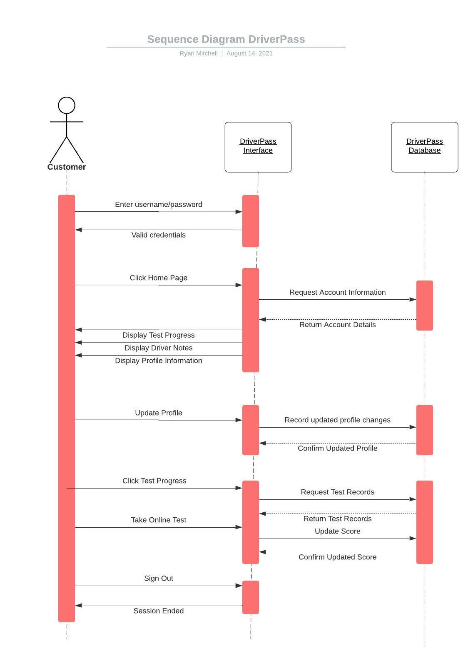

### UML Class Diagram

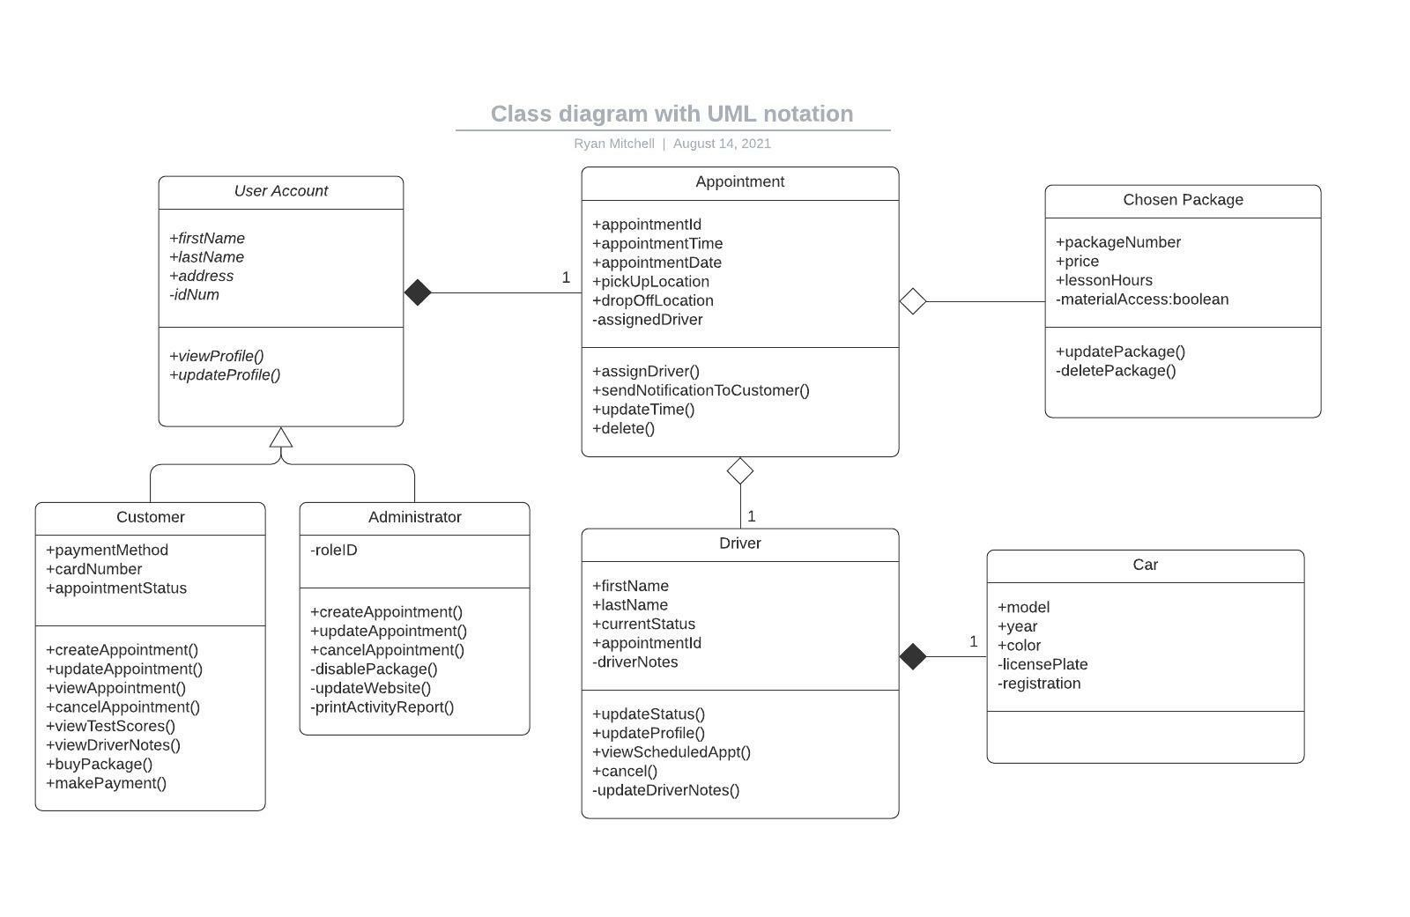

## Technical Requirements

For the development of this system, the team will need access to:

* Standard Java development tools/utilities
* Web development tools
* Cloud service/database integration and access
* Windows/Mac OS computers and mobile devices
* High speed/reliable internet

Given the overall simplicity of the system being designed, a small team of developers with proficiencies in Windows/Mac/Linux will be preferable to help ensure compatibility across all major browsers and operating platforms.